Surprising Encounters
Primary School Pupils Co-Create Meaning and Sense in Dialogue with Biblical Source Narratives

Bas van den Berg
Esprit de Finesse
W. Barentszstraat 85
3572 PE Utrecht.
E: bwp.vdberg@ziggo.nl;
M: +31 619152639

15 September 2019
Surprising Encounters
Primary School Pupils Co-Create Meaning and Sense in Dialogue with Biblical Source Narratives

‘Now we are here; next year in the land of Israel.
Now slaves; next year we shall be free’ (Pesach Haggada).
Abstract:

In this contribution we want to explore the concept of ‘history’ at a deeper level as: historical events conceived as source narratives, demarcated by a beginning and an end, which are charged with meaning. In the Hebrew Bible, ‘history’ is the story of how human beings, led by the sound of a voice – a calling – began the long journey to a promised land and to a messianic age, in which people build a society that honours the image of God in others, form families filled with trust and love, shape communities according to the principles of justice and compassion, and live in peace with their neighbours. More specifically, we want to reflect on the concept of ‘covenantal time’, coined by the British philosopher and Chief Rabbi Jonathan Sacks (Sacks 2013), a concept that was already explored in the philosophical studies that Paul Ricoeur collected in his work Temps et Récit (Ricoeur 1983/1984/1985), and which was transferred to the domain of education by the educationalist Kieran Egan (Egan 1986, 2005).
In this article we want to explore the relationship between the concepts of time and narrative in the domain of contemporary religious/worldview education. We claim that the awareness of being a part of an overarching narrative with a sense of origin and destiny forms the foundation on which religious education programmes can be further developed in the cultural and educational context of the Netherlands. By choosing a single scene from a story in the Hebrew Bible as our cultural source narrative – namely the reconciliation between Joseph and his brothers (Genesis 45,1–14) – we will expand on life and societal themes that are significant for 21st century primary school pupils, in regard to their quest for a personal life orientation. The ideas and insights of Kieran Egan will support us in our narrative and imaginative quest for sense and meaning.

Keywords: cultural source narrative, narrative of hope, covenantal time, inventive imagination, dialogical responsiveness, creative reinterpretation.

Bas van den Berg
Professor Emeritus in dynamic identity development of teachers and learners, dialogical worldview learning, and co-creative meaning-making in the workplace, at the Marnix Academy, teacher training institute in Utrecht, 2004–2018.

- Introduction

‘ Time is the narrative of the human journey,
a journey undertaken with hope because,
although the way is long and hard, we are not alone’.

This article provides an exploration and clarification of various aspects that pertain to the field of tension between the concepts of time and narrative. Both these concepts are relevant in the context of religious education (RE) and refer to the theme of the 2019 ENRECA conference, ‘Time as Context’. In this article, we refer to four key concepts that were set up at the beginning of the conference: Chronos, Kairos, tradition and hope; concepts that were subsequently deepened in a second round of reflection, by drawing upon a series of religious (teleological: linear and cyclical), historical (time as ‘a chain of memory’), social science (‘the description and interpretation of events and changes’) and pedagogical connotations (‘passing on treasures from the past to young people in the humanities, into the future’).
The concept of ‘covenantal time’ in the Hebrew Bible combines a linear and a cyclical view on time, and transfers the concept of ‘time’ from a natural level to a historical, ethical and spiritual level. The ‘covenant’-concept is intimately related to time. This is because achieving a free and just society is not the work of a single moment, but of many generations, and because it is not only the result of the commitment of G’d, but also of the commitment of countless men and women, i.e. human beings created in His image. In Egypt, Israel experienced both oppression and the yearning for freedom. For these reasons, the ‘covenant’-idea is essentially linked to education and memory, for the journey is long – and only when each generation passes on what it has heard, learned, and prayed for to the next generation, the journey will continue; and only when the journey continues, will history be redeemed. Out of this kind of self-consciousness the narrative of Exodus was born, namely by retelling the story in the so-called Haggadah (= the Narrative) – ‘generation by generation, each person must see himself as if he himself had come out of Egypt’ (as said by the sages of Israel, quoted in the Haggadah). That is, the Israelites acquired a consciousness and a sense of beginning and destiny, rooted in a remembering of affliction and slavery, and in a yearning for a destiny and freedom in a just society in the distant future. This was the time of the birth of the capacity for hope in – and between – human beings as a response to a divine call. The Exodus narrative is the first great human ‘narrative of memory and hope’, told through the metaphor of a journey from servitude to freedom, retold and re-enacted in the present for the sake of the future, bearing in mind the goal of living together in a just and sustainable world.
Worldview education and RE interpreted as life orientation, practiced as a permanent quest of primary school pupils to get hold of their identity, and perceived as the construction of a personal life orientation, is not a well-known and prevalent concept in primary schools in Europe. In the majority of cases, learning processes are set up to begin at the other end: important resources of religious traditions are unpacked and interpreted in a linear fashion in a religious educational setting. Since the 1990s, a major question has arisen in an increasing number of European primary schools: ‘How do we create a more co-creative learning environment to realise an intensive encounter between the world of these cultural source narratives and the life world of the pupils, paved with dilemmas, life themes and life questions?’
It should be noted that for many schools, the pedagogical goal is not to enable a co-created connection between the wisdom embedded in these narratives and the life world of the pupils, who are looking for a valuable orientation to hold on to in their lives, in a vulnerable and uncertain world. Instead, the pedagogical aim is simply to present and reproduce the content/knowledge contained in these cultural source narratives. Seen from both sides – the perspective of the pupils, and the perspective pertaining to the stories themselves – the prevalent practice in RE really amounts to a missed opportunity, in regard to possibilities for meaning-construing by the pupils themselves, through the enhancement of their symbolic literacy. Only when pupils – in collaboration with each other – develop a sensitivity to the symbolic language contained in cultural and religious narratives, and acquire the ability to relate their personal and social lives to the life events of the characters in such narratives, can the continuation and the renewal of such a living culture be stimulated, continued and emerged.
In 2004, we began to develop an innovative educational approach of this type, based on a new method for transmitting and appropriating the knowledge and wisdom of the past that is embedded in cultural source narratives. Our research project starts from the assumption that this form of wisdom is expressed and imagined in stories filled with metaphorical language. When primary school pupils learn to become aware of – and play with – the meaning and sense contained in this kind of figurative language, their symbolic or metaphoric literacy grows, as does their ability to apply this symbolic/metaphoric awareness to questions and issues they face in their everyday life in the 21st century. When presented in a way new generations can identify with, the life experiences of older generations – expressed in the form of myths, narratives, poems, songs, rituals and other cultural products – open up a learning space imbued with new images and ideas, which can serve as a support and an inspiration to young learners in search for an individual life orientation. When valuable cultural source narratives come into contact with the lives of primary school pupils, providing notions of time, past, present and future, as well as the awareness of being a link in the ‘chain of generations’, the ongoing process of identity development and civic education, activated by the acts of remembering and yearning, are constantly revitalised.
To explain our pedagogical approach, we present in this contribution some findings of a research project that we carried out in 2010 in two primary schools in the Netherlands. The project was based on our search at the time for a new way to confront various cultural, moral and spiritual source narratives with life questions and life themes of primary school pupils living in the 21th century. We defined this new approach by using three terms: imaginative, dialogical and reflective. The key concept in this tridimensional model we designed is the co-creation of meaning and sense by learners themselves in the process of co-interpreting, co-dialogising and co-reflecting on a specific cultural source narrative in an interactive and creative learning environment. By drawing upon a single scene taken from a story in the Hebrew Bible – namely the reconciliation between Joseph and his brothers (Genesis 45,1–14) – we illustrate this process of co-appropriation of existential-ethical wisdom (knowledge and insight) by learners in primary schools, and how present-day life themes can be enriched in dialogue with age-old narratives. The life theme we focus on in this article is that of ‘violence and reconciliation ’.

- Conceptual Framework
In the studies of the French philosopher Paul Ricoeur, the concepts of time and narrative are intimately related. In his magnum opus Temps et Récit (‘Time and Narrative’, 1983/1984/1985), Ricoeur underlines that designing a narrative opens up a landscape of possibilities, a horizon of new meanings – a vista which may appeal to students in life orientation. Listeners who hear a story and vividly represent it, respond to one of these possibilities by means of actively exerting their imagination and expressing themselves through drawing, text-writing, role-playing or interpretive dance. In the emerging dialogue between the narrative and the responses of the pupils, an interspace for new meanings and sense will be created, while simultaneously a second interspace for new experiments in value-driven (inter)actions is opened up. According to Ricoeur, narratives – as a genre – are particularly suited to enable students to explore and research their personal life events, by linking these life events with the actions and dialogues of characters in attractive cultural and worldview narratives.
In his concise book On Stories, Richard Kearney (2002) elaborates a third aspect of the relationship between time and narrative: time in the narrative as linked to the historical time (age) of the world in which the listeners/readers of the narrative live. The highest achievable outcome of an encounter between the world of a cultural source narrative – when imagined and actively performed by the listeners/readers – and the world and the time the listeners/readers are inhabiting, is the opening of a new horizon that leads to the discovery of a new possibility to act, dialogue, or think.
Our third conversation partner, the British philosopher and Chief Rabbi Jonathan Sacks (2013), develops an in-depth reflection on what he calls ‘covenantal time’, in studying the Hebrew Bible and the reflective commentaries collected in the Talmud and the Midrash. In coining the concept of ‘covenantal time’, Sacks does not speak of time as ceaselessly flowing forwards, but as a narrative demarcated by a distant beginning and a distant end, in the midst of which we find ourselves, and whose twists and turns continue to surprise us. In the Hebrew Bible, ‘time’ is intimately connected with the remembering of decisive historical events. Remembering such events, and the attractiveness of these events to present-day communities and individuals, creates a sharp awareness for what might count in the building of a good life in a just society. The sharpening of this awareness is dependent on the availability of a space of learning, where past events can be collectively remembered and retold for the sake of the future. According to the outlook of the Hebrew Bible, the life journey of human beings is marked by continually recurring life themes, such as exile and redemption. In this biblical ‘narrative of memory and hope’, the concept of linear time offers an insufficient grasp on what is at stake. There is no guarantee that progress will be made in the course of history. Above all, the concept of ‘covenantal time’ is linked to an awareness of our limits in dealing with nature, and with our fellow human beings. Linear time, the dominant concept of time in economics, politics, and science since the 17th century, is related to the idea of unlimited growth, which gives rise to optimism. Optimism is the belief that things will get better. In the biblical concept of time, hope is the leading idea. Hope, unlike optimism, is the belief that together we can make things better. This concept of time gives rise to the notion of Emunah, which is usually translated as ‘faith’, but might be more precisely rendered as ‘reciprocal trust’, an utterly unique concept in the religious language of mankind. Emunah does not imply certainty; on the contrary, it refers to the courage to live with uncertainty, knowing full well that the future is radically unpredictable, but realising that it can be faced without fear, because we are not alone. G’d and His Word are with us. In sum: the Hebrew Bible presents a very specific concept of time in a sustained attempt to see events through the prism of Emunah, which results in an understanding of history as the ongoing interaction between heaven and earth, between the Divine Word and the human successes and failures in hearing and acting upon this Word. The Hebrew Bible is imbued with the idea of a covenant – as a partnership initiated by G’d, and entered by mankind – making G’d and mankind partners in the work of redemption.
This brings us to our fourth conversation partner, Kieran Egan. Since the 1970s, this pedagogue, philosopher and educationalist has been fascinated by the way in which life stories and life rituals create an awareness among young people from indigenous cultures (located along the coast of Alaska) for the living reality inside of them, surrounding them, and embracing them. This sparked an imaginative approach to teaching and learning in Egan’s mind. In all his books since the 1980s he has been developing this key intuition and related insights in different directions. The concepts of ‘narrative’ and ‘time’ figure heavily in his ‘philosophy and pedagogy of sense-making’.
The ideas of these four authors will help us to explore our major assumptions, as articulated in this article. Our general research question is: ‘To what extent is it a matter of urgency for the life orientation development of 21st century learners to enter into dialogue with strong cultural source narratives from a variety of worldview traditions?’. With regard to primary education, we ask: ‘To what extent it is a matter of urgency for 21st century primary school pupils – living in present-day social, political, and cultural contexts – to enter into dialogue with strong cultural source narratives, assuming that we want to enable them to discover new perspectives on their personal reality (mental, social, moral, and spiritual/existential)?’. In this article, we follow primary school pupils as they respond in their personal and co-creative ways to a source narrative. Through this learning process, it seems achievable that new forms of self-discovery and self-understanding will come into being for young people, and that an engagement and an interest in the world to come (with a spiritual, a human, a cultural and natural dimension) will be triggered and nourished in them.

- The Cultural Source Narrative of Joseph and His Brothers

Cultural source narratives, both in the Hebrew Bible and in the New Testament, are a mix of fiction, history and morality, which means that all such narratives can be regarded as value-driven stories focused on existential and spiritual life experiences. As such, they would have had an intense impact on the life events of listeners/readers of bygone ages, just as they can have a genuine impact on listeners/readers in the 21st century, who struggle with life questions and life themes as well.
The famous narrative of Joseph and His Brothers serves as an example of this mix of fiction, social and societal events, and the ethical dimension that they contain. This narrative covers chapters 37–50 of the Book of Genesis, and consists of a series of stories with a good sense of suspense, human rivalries, and situations at the edge of the visible and the invisible world within us, surrounding us, and stretching beyond the world we live in.
Joseph, son of Jacob and Rachel, lives in Canaan with his twelve siblings. He is the favourite son of his father, entitling him to special treatment. This causes his brothers to resent him and to plot his ruin. They plan to kill him, but eventually sell him into slavery. Joseph ends up as a slave to the house of Potiphar in Egypt. Jacob, his father, is overwhelmed by intense feelings of grief and bereavement, because he believes his son dead. Many years later, when Joseph has become a person of power and influence at the court of the Pharaoh, his brothers fear that he is bent on revenge. Surprisingly, he answers with the sentence: ‘You intended to harm me, but God intended it all for good’ (Genesis 50,20). It is not unimportant that the Book of Genesis comes to an end with such an interest in human and social affairs. The whole book is a series of variations on the themes of sibling rivalry and violence between human beings. In the quoted sentence, Joseph shows how to move beyond the cycle of conflict and violence. The issue that sets up the story is how the brothers handle rivalry, envy, revenge and violence. A question that can be contemplated while exploring this narrative is ‘What types of conflict resolution can be found in this source narrative?’ A second question is: ‘In what way and by what means is G’ds presence and commitment represented in the story, and how does this divine concern influence human affairs?’

The scene from the Joseph saga we single out to illustrate the process of co-creative meaning-making on behalf of pupils, is entitled ‘Joseph Reveals His Identity’ (Genesis 45,1–14) and revolves around the theme of violence and reconciliation. This scene provides a moving insight into the way Joseph reconciles himself with his brothers, his father, with his own person, and with the Infinite. We describe and interpret this passage successively from the perspective of the sages of the Jewish tradition (their wisdom and way of life) and from the perspective of 21st century Dutch primary school pupils (children’s life questions and life experiences). In order to do so, we first need to present and evoke the dynamics of the scene, a presentation that will be focused on the concepts of time and narrative. In a second step, we will explore the field of tension between the world of the narrative and the life world of the listeners/readers on a deeper level. This exploration will be tied to the life theme of violence and reconciliation.

- Covenantal Time in the Narrative of Joseph and His Brothers

‘Narratives of memory and hope in the context of violence and reconciliation’ (Sacks 2016), such as the Joseph saga, are embedded in existential and spiritual grassroots experiences of communities that existed in social, cultural and mental contexts – not to mention times and places – that are quite different from ours. The stories handed down to us in the Books of Genesis and Exodus were construed in the fifth century BCE in the community of Jewish exiles who lived in Babylon. Their literary and imaginative composition is the outcome of a long oral tradition, in which stories about the forefathers and foremothers were retold and enriched with new details in ever-changing environments, each with its own challenges, possibilities and disasters. The literary genre of ‘narratives’ – once created – offers the possibility to enter into dialogue with the attractive images in such source narratives, which present ‘well-ordered’ real-life experiences of people that unfold in situations (contexts) with clearly defined names, places, times and circumstances. Such narrated existential images of real-life experiences are construed to help later generations to compare their life world with the narrated world of the characters. From the fifth century BCE onwards, this process of constructing source narratives from different and ambiguous life events created a community of listeners/learners who are in a position to construe new interpretations of the source material, called ‘Midrash’ (both as an interpreting practice and as a body of texts) in the Jewish Tradition. Such a process of reading, retelling and re-interpreting the sacred texts gave the Jewish – and later: Christian – communities a distinct sense and awareness of time, and also transformed the common understanding of the role of religion in the making of society.

The etymology and deeper meaning of ‘religion’, which has a basis in ‘connecting’ (‘religare’), gains two new meanings by this kind of religious practice: on the one hand, ‘re-interpretation’ (a process of re-interpreting the transmitted ‘myths’, rites and values) and, on the other, ‘re-cognising’ (the re-cognition of the dignity of every creature] and ‘re-enacting’ (new ways of interacting with human beings, in relation to the culture they live in). This renewal process of the role and function of religion not only deeply transformed the religious and temporal consciousness of the time, but also the practice of learning and teaching. When the Torah as a sacred text became the centre of weekly reading, retelling and interpretation, this was the birthplace of a new kind of collective learning: not to legitimise the sacral and hierarchal order of a society in which kings were worshipped as gods, but to form a learning community of equals, with a shared, equal responsibility to renew the process of living together in a free and just society. When such a community of learners meet, they recall the important events of the past to support the members in their social and societal tensions, to strengthen their hope, and give them courage to act in compassion, trust and love. A process of representing and re-enacting the inspiring source narratives, i.e., of remembering the decisive and significant moments of the represented past in the present, invites the listeners to connect with the dynamics of the source narrative, to reflect together in a dialogical way on these powerful past events, and to research such narratives together, which brings the internal dynamics to life in a new context. The outcome of such a RE process, which manifests itself in both living and learning, is the re-creation of the personal, social, and societal culture the learners are involved in. Viewed in this way, the ongoing process of RE can be characterised with three words: remembering, re-interpreting and re-creating, of the three dimensions of reality: mankind, the world and G’d.

- Dialogical Responsiveness of Pupils

When presented in one format or another, source narratives such as the Joseph saga trigger the pupils’ imagination and emotions. This probably happens because these narratives are –precisely – based on a ‘covenantal concept of time’, embedded in the aspect of human experience that stands in an intimate relation to a transcendent future, which is being expressed in a story with characters, events, a plot and a development. The impact of a source narrative performed on stage (in play format) is dependent on the responses of the spectators, the choices they make when they witness the performed narrative, and the alternative possibilities they can imagine when identifying themselves with characters in scenes that appeal to them, in terms of existential and spiritual life themes embodied in the narrative. Paul Ricoeur (1995) argues that narratives are essential for human identity formation and for our human sensitivity to emerge, in terms of individual and social humanisation. This might be the reason why biblical narratives are so appealing to the imagination of new generations. The majority of the characters are ordinary people with whom we can identify – not distant gods, heroes or other alien characters.
Primary school pupils love to listen to vividly presented stories. They want to know what is going to happen next, about things they cannot be sure about in advance. Storytelling is a perfect tool to engage the imagination of the pupils, stimulating them to become more sensitive to the natural, cultural and spiritual dimensions of the world. In a well-composed narrative, nothing is certain. Will Joseph’s brothers eventually repent? Will Joseph, who is sold as a slave to traders on the road to Egypt, eventually be freed, and be able to live his life as a responsible citizen in the society of his time? The ways human beings respond to a situation can never be fully predicted. This is the reason why telling and performing cultural source narratives in the context of RE lessons is the first responsibility of the RE teacher. In our approach, we present cultural source narratives as multi-faceted and multi-interpretable narratives that invite pupils to come up with their personal and free responses, from their individual perspective and related to their specific needs, in the social and societal context they live in.

In the 14 years that this article’s researcher worked as a teacher trainer, lecturer and researcher in the field of RE/worldview education, he discovered that when students enter into a dialogue with cultural source narratives – whether they originate from the Jewish, Christian, Islamic, or humanist tradition – these reveal themselves as ‘sources of meaning’ that equip pupils – regardless of the cultural context from which they come – with tools to face the unknown future, and give them opportunities to discover new meanings and acquire new insights. The pupils are likely to discover hints or indications that will help them in their search for their own life orientation. This is because all these narratives from different religious traditions follow the same format: they portray a situation in which one of the key values in a civil society, such as loving kindness, justice, mutual trust and responsibility, is at risk.

When ‘covenantal narratives’ are presented – in one format or another – they can disclose insights and challenges for readers/listeners/spectators of new generations. When students of new generations begin to respond to such source narratives in a dialogical way, they are in a position to discover meaning and orientation to nourish their everyday lives, and to aid them in their quest for a personal life orientation.
Abraham Jehoshua Heschel (1907–1972 coined the term ‘responsiveness’ to capture the way in which readers/listeners/spectators ascribe meaning to a cultural source narrative. He articulated this concept while reflecting on a basic concept conceived by Martin Buber in the midst of the violent clash of WWI, namely that of real dialogue. Buber (1954) described the differences between the attitude of the ‘I’ towards an ‘it’, and the attitude of the ‘I’ towards ‘Thou’ – two ways human beings can relate to the outside world beyond and surrounding them. Buber found that a dialogical relationship with others is not just possible because of the existence of others, but also because of the existence of the wonderful world of nature, and the invisible world surrounding us. Developing this line of thought, he expanded the concept of ‘dialogue’ by opening it up to the world of things and artefacts. By extending the concept in this manner, he makes it possible to think in a more holistic, interactive and co-creative way about the encounter between open-minded readers/listeners/spectators and a valuable source narrative, as well as about the internal dynamics of such a narrative in relation to a key existential-ethical life theme. After Buber developed this understanding of the dialogical relationship, a reorientation took place in the fields of philosophy of life and hermeneutics of cultural and religious source narratives, leading to new models for the interpretation of texts and social situations, thereby creating a platform for new generations to confer meaning to important cultural artefacts.
In light of Buber’s development of the concept of ‘dialogical relationship’, Heschel’s concept of ‘dialogical responsiveness’ acquires a deeper meaning. Heschel was intimately familiar with a long tradition of Jewish creative and imaginative reading of cultural source narratives in the Midrash tradition (Heschel 1955/2005, 1962/1992). The Hebrew word is derived from the root of the verb darash, which means – among other things – ‘questioning’, ‘wondering’. In Jewish hermeneutics, the tradition of midrashic reading of religious source narratives originated in the second century BCE and went on to produce works in a very refined style, as well as literary forms of a high quality. In this ‘sea of narratives’, the variety of metaphoric and symbolic language is a salient feature. In the project to design a research & design setting for the project in the spring of 2010, which will be outlined below, we – as teachers and researchers – opted for a midrashic-fashioned programme. Using various tools, the pupils were challenged to enter into a dialogue with two selected scenes from the Joseph saga.

- The Organisation of an Interactive, Co-Creative and Reflective Learning Space
To outline how we – as teachers and researchers – can co-create a learning environment in which pupils can get acquainted with the symbolic language of cultural source narratives, we describe the research & design setting we implemented in two Dutch primary schools in the school year 2009–2010 (Van den Berg 2014).

In the spring of 2010, we organised a one-week project at primary schools de Polsstok in South-East Amsterdam, and de Wonderboom in North Amersfoort (both of the confessional school type). The project focused on stimulating pupils to enter into a dialogue with several scenes of the Joseph saga. A collection of instruments were used to generate data about the verbal or visual expressions of symbolic language produced by the 9 to 10 year olds. Among these instruments were so-called verbal ‘provocations’ that challenged pupils to engage in conversation, both amongst themselves and with their teacher. The teachers and researchers also created written assignments that invited the pupils to produce visual and literary creations (drawings, symbols moulded from clay). Further instruments used were different forms of interaction, dialogue, play (role-playing) and reflection (based on comic reading and diary writing, for example).
During the preparatory sessions with the teachers of the two primary schools, we developed a script for each day of the week, each time focusing on a specific didactical tool to invite the pupils to access – and respond to – the dynamics of the symbolic language contained in a scene from the Joseph saga. On the day that the teachers used a combination of a literary, dialogical and playful access to the Joseph saga, they practised forms of writing, dialogue and drama they were familiar with through their daily teaching practice.

- The Responses of Pupils to an episode about ‘Dreams’ and ‘Reconciliation’ in the Joseph Saga

The episode of the Joseph saga we selected, ‘Joseph Reveals His Identity’ (Genesis 45,1–14), turned out to be a great success, in the sense that it deeply moved the pupils in the classroom. Not only did the pupils read the narrative together in advance, to make them sensitive to what occurs in this particular situation between Joseph and his brothers, but they also watched scenes of a movie called Joseph: King of Dreams (DreamWorks Pictures 2000). The movie offers a very exciting presentation of the Joseph saga as covered in chapters 41–47 of the Book of Genesis: the suspense, the tension and the awe that the story in the Hebrew Bible evokes has been successfully and creatively adapted in the script of this movie.
Two decades after Joseph’s enslavement, the situation is as follows: a famine has broken out in Egypt and the surrounding territories, such as the land of Canaan, where Jacob and Rachel continue to live with their remaining children. Jacob sends Joseph’s brothers to Egypt to buy grain, to ensure the family’s survival. Joseph, in the meantime, has ascended from the position of a lowly slave to the house of Potiphar to the position of Vizier, ruling alongside the Pharaoh as his right hand. Through his special gift as a dream interpreter, he is able to interpret the Pharaoh’s prophetic dreams – a feat no other advisor to the Pharaoh is capable of. Joseph was thirty years old when he entered the service of the Pharaoh, thirteen years after he was sold into slavery by his brothers. As dream interpreter, he has aided the Pharaoh in interpreting a crucial dream, which predicts seven years of bountiful harvests followed by seven years of famine. Therefore, he counsels the Pharaoh to carefully stock the surplus. During the seven years of abundance, Joseph ensures that the storehouses are filled with grain. When the famine comes, it is so severe that people from the surrounding territories come to Egypt to buy grain. This is how Joseph’s brothers – with the exception of Benjamin, the youngest brother, who stays in Canaan – end up standing before the Vizier, whom they do not recognise.
The story is beautifully told in the Book of Genesis, and offers plenty of excitement for good listeners and readers, who can gradually discover the plot through the subtle hints in the narrative, provided they give the story their full attention.
In de Wonderboom and de Polsstok, a series of teaching methods and work forms were prepared in advance to trigger the pupils’ imagination and emotions, to stimulate them to enter into a dialogue with the story and to challenge them to ascribe meaning to the story, in relation to their inner world of feelings, intuitions, fears and expectations, their perception of their cultural environment, and their own life world (family, friends, school, society).
In one assignment, the pupils were invited to remember their past dreams, to record current dreams, and to share these with their classmates. In another assignment, they were invited to work in pairs to create a newspaper of dreams in which they showed images of their fears and hopes for the future of mankind, for animals, for society, and for all of creation. In the first example below, two girls used pictures to send the message that animals ought to be treated kindly, money should be given to poor children, and animals should not be used as test subjects in laboratories. They added texts like: ‘Let animals live, don’t let them die!’

Newspapers of Dreams
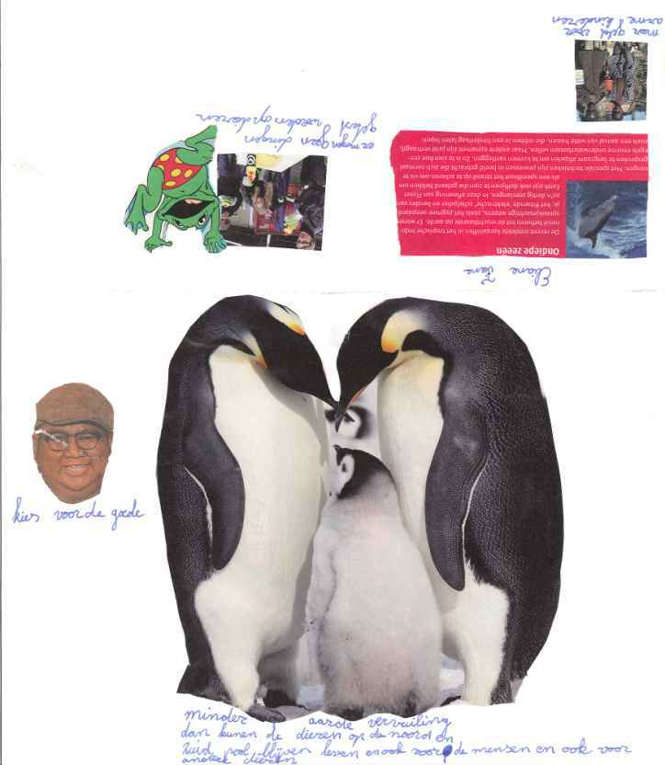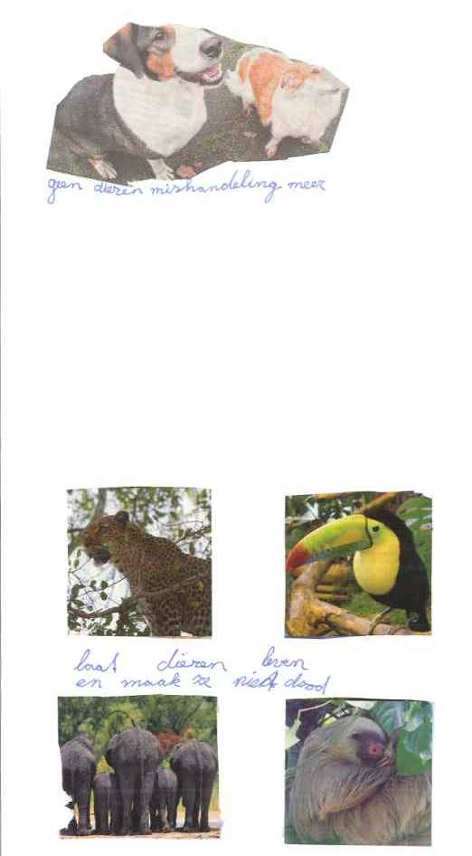
Figure 1: Newspaper of Dreams, Foka & Elize: de Wonderboom, June 2010.

In the second example below, two boys used pictures to communicate hopes and fears of a different kind. They imagine a high-tech future with electric cars but worry about the drug trade that causes problems all over the world, and about the many wars that are going on. They also show their affection for the world of nature.

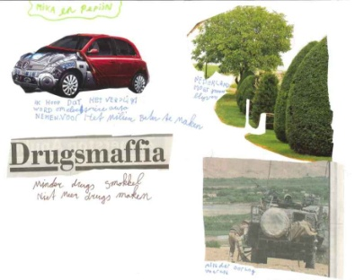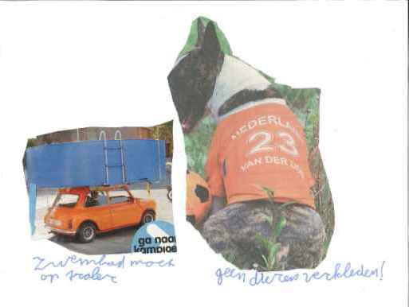
Figure 2: Newspaper of Dreams, Michiel & Bram: de Wonderboom, June 2010.

These pupils prove themselves capable of imagining the natural and the cultural world around them in a very concrete and detailed way; they are also concerned about the well-being of animals and the environment, about wars, and people living on the margins of society. They are connected to these kinds of real situations on an emotional and an imaginative level. These ‘newspapers’ are windows to their inner world. The link with the Joseph saga lies in the power to dream of a better future, to live in and to live for. This type of creative expression of 21st century primary school pupils, living in a modern time and context, creates bridges with a narrative that dates back 25 centuries.
There was one shot in the movie Joseph: King of Dreams that touched all of the children, in both classrooms/schools. This is the moment when Joseph, now Vizier of Egypt, sees his father again after being separated for many years, and they are reunited after much sorrow and pain (‘Jacob’s Family Arrives in Goshen’, Genesis 46,29–30). This scene comes after the scene we singled out to illustrate the process of co-creative meaning-making on behalf of the pupils, entitled ‘Joseph Reveals His Identity’ (Genesis 45,1–14) (see above). Joseph chooses the moment to reveal his identity to his brothers very carefully, first making sure that his brothers, step by step, become fully aware of what they did to him when they sold him as a slave, with the result that when Joseph meets his brothers for the second time (when they return to Egypt with the youngest brother, Benjamin, as per the Vizier’s instruction), he is secretly weeping. When he reveals to them who he really is, he first embraces his youngest brother Benjamin, and then kisses each of his brothers. By building up the narrative with such tension and suspense, readers/listeners/spectators can identify with what is happening, and understand step by step the transformation of the brothers from strangers to people of violence, to brothers in the sense of family, and finally to responsible human beings – for the good of all.

- Insights Acquired by the Pupils in Their Encounter with the Joseph Saga

  - Surprising Encounters
In paragraph 1 we stated that the activation of primary school pupils’ faculty of imagination and their capacity to enter into a dialogue with cultural source narratives, can serve as a valuable support in their search for an individual life orientation, in these late-modern times. More specifically, we claimed that becoming literate in symbolic language, such as metaphors, can enrich the vocabulary of 21st century pupils in light of their need to develop and express their worldview, lifestyle and life stance. In short, we claim that the dialogical, creative and reflective encounter with a dynamic source narrative can enhance pupils’ awareness that human beings live in a society, and that an individual’s good life in a community is embedded in a chain of events connected to previous generations, all of them with a specific past, present and future. Secondly, we argued in this contribution that the quest of pupils for a personal life orientation can be stimulated and challenged by a covenantal source narrative such as the Joseph saga, which wakes up a sense of hope and a sense of future for all, in belonging to a community and being part of it, and by collectively working on a world with more peace, more justice, and a sustainable life for the whole of creation.
An important component of our narrative and discourse is Paul Ricoeur’s insight that introducing pupils to ‘strong narratives’ is a very good vehicle to make them sensitive to the fact that the aspiration to live as human beings in a just and sustainable society is a human endeavour that can be ‘read’ and ‘understood’ through the medium of well-structured narratives of life experiences, which are gained at specific moments and in specific situations. On the individual level, every pupil has to seek his/her own way, while engrossed in the process of becoming an individual with a sense of destiny and responsibility in the public domain, which inevitably involves reflection on complex and ambiguous life questions and life themes, such as ‘violence and reconciliation’. Cultural source narratives encountered by new generations on their personal journey, can serve as vivid and strong counter-voices in the midst of social and societal circumstances, both the negative ones, such as prevalence of envy, greed and fear, and the positive ones, such as peace, just relations and mutual trust. Especially when pupils become sensitive to the metaphorical and symbolic make-up of these kind of narratives, and the dynamics of inventive imagination that produced them, an interspace for new meanings can be opened up, which unfolds a landscape of new possibilities in terms of living together, and for fostering dreams of a just and sustainable society. Whenever such a dynamic source narrative is performed and retold in a specific context by committed and inspired teachers, for a specific public and with a specific purpose in mind, it will make an appeal to participating readers/listeners/spectators, and will unfailingly evoke personal and communal responses on behalf of these participants.

8.2 Surprising Encounters in the Field of Tension Between Time and Narrative
In working with particular scenes from the Joseph saga – the reconciliation of Joseph with his brothers (Genesis 45,1–14) and Joseph seeing his father again after being separated for many troubled years (Genesis 46,29–30) – we found that when Dutch primary school pupils are challenged to enter into dialogue with the symbolic language of cultural source narratives, and to share their insights and ideas in a dialogue with their peers, and in an inner dialogue expressed through various assignments (comic reading and diary writing, for example), they find orientation in their present-day, modern lives. In addition, we note that such educational experiments may also spark ideas about the future they will have to confront in their present life world. The condition for this type of development is that pupils are trained in the understanding of symbolic language, and are properly guided in improving their literary and visual capabilities, as well as their capacity to engage in a dialogical exploration of these narratives with their peers who, like them, are on their way to acquire a personal and communal life orientation.

Biblical narratives such as the Joseph saga have an intrinsic power to appeal to readers/listeners/spectators, and offer the possibility to be creatively (re)interpreted by new generations, provided that they succeed in the re-figuration, re-enactment and re-creation of the plot, life themes and life questions of the story – in a meaningful relationship to their own life context and situation. Understanding the Joseph saga in the symbolic mode can open up new horizons for present-day learners.
In paragraph 2 (‘Conceptual Framework’) we discussed the field of tension between narrative and time in the oeuvre of Paul Ricoeur, Richard Kearney, Jonathan Sacks and Kieran Egan. Primary school teachers who, with the help of cultural source narratives, accompany students in their quest for a personal life orientation, are dealing with three dimensions of time: the time within the narrative, the time that has elapsed between the construction of the narrative and the present era, and the time in which the teachers and learners are living, 21st century Western Europe. These three dimensions become present from the moment learners enter into a dialogue with a cultural source narrative in their learning environment. A striking feature of the encounters with biblical source narratives are the dynamics of the reciprocal connection between time and narrative. In the words of Jonathan Sacks: ‘Time is the narrative of the human journey, a journey undertaken with hope because, although the way is long and hard, we are not alone’ (Sacks 2000, p. 178).

8.3 ‘Telling the Time’: The Pupil Perspective
Pupils that are engaged in this dialogical, imaginative and reflective way to explore life themes, through dialogue with an unknown and unusual cultural source narrative, are liable to develop new insights and ideas. As they become familiar with the power of symbolic language, their capacity to express real life experiences – through empathy, imagination and the capacity to respond creatively to a natural or cultural phenomenon outside themselves – begins to increase. Through their development, facilitated and stimulated by their teachers, the pupils of de Polsstok and de Wonderboom discovered the courage to enter into an authentic dialogue with an image from a movie, or a sentence in a story.
The project in the spring of 2010 made it clear that it takes time for learners to understand expressions full of symbolic language, that it takes them even more time to acquire the ability to communicate in symbolic language, and that the most difficult thing of all was a third developmental step: acquiring the ability to express oneself in a literary, visual, dramatic or musical form, in such a way that the chosen expression is coherent with the idea or insight of the author of the narrative.
It takes time, as well, for learners to see how a narrative is composed, and to discover the equilibrium between the amount of time it takes to tell a story and the chronology a narrative is referring to. In order to become sensitive to the meaning of a source narrative, and more specifically to the different meanings that you, as reader/listener/spectator, can ascribe to a story, image or song, time is required for experimentation, dialogue and reflection – as well as the openness to engage with different voices. It is the task of teachers to guide the pupils’ process of dialoguing with peers, and with the source narrative, in a learning environment in which the space for a plurality of voices is guaranteed within a continuing dialogue.
In addition, pupils can explore different commentary voices to shape their own responses to an attractive source narrative. In such a process of continuing dialogue, reflection, and vivid imagining of source narratives, all in relation to real life experiences, pupils are sometimes struck by a surprising insight they keep thinking about, or an idea that motivates them to continue exploring the story at a deeper level. As the learning process continues, they become so curious about what will happen next, that a process of lifelong learning is born that will never stop. At such a moment of ‘telling the time’, both the past and the future are present in the valuation and evaluation of the narrated events.

8.4 ‘Telling the Time’: The Teacher Perspective
The teachers involved in the one-week project in de Polsstok and de Wonderboom became aware of the voices of their pupils, during the pupils’ appropriation process of symbolic language. Partly due to their training and also out of love for their subject, teachers tend to be the ones who speak in class, and use up the time for learning. Precisely in the case of a subject like RE/worldview education however, the key is to invite the pupils to think for themselves and to invite them to articulate in their own words what they think or feel, for example, about the actions of a character in a source narrative. The transition from simply passing on subject matter to challenging one’s pupils to explore a source of meaning together, is a complex one. It is a complex transition in the sense that teachers need a lot of time and practice to become aware of their pupils’ voices, needs and questions in the domain of RE/worldview education (Van den Berg 2016).
A number of insights can be reported. First of all, it could be derived from the project that teachers Joris and Janine radually became more sensitive to their pupils’ own, and different, voices. The more experience they gained with letting children play with the symbolic language of a source narrative, the more sensitive they became to the pupils’ own voices, and the uniqueness in every pupil’s contribution. The more concrete their questions and instructions to the pupils became, the more powerful the voices of the pupils resounded and the more their eyes started to shine.
Secondly, in course of the project, these two teachers discovered and mastered new methods that allowed them to give shape to pupil-oriented RE/worldview education. They discovered that, as professionals, every creative method required them to draw on specific capacities, and to activate specific abilities. They discovered the power in challenging their pupils to come up with their own answer to a question. This, in turn, required them to adopt a basic attitude characterised by an open, flexible and involved attention to what was taking place in the interaction between the pupils, a life question or life theme, and a source narrative. An attitude that prompted them to act more consciously and wisely in concrete teaching situations. This attitude required them to display a specific kind of openness, which prompted them to act inventively and assertively in such a way that pupils who were reluctant to speak up, began to participate.
Teachers who learn to act wisely, boldly and inventively in these kinds of teaching situations, dare to begin the search for meaning with their pupils, and in that process learn to interact with pupils in a more flexible and natural manner. This process goes hand in hand with falling over and getting back up again, and every school deserves space and time in order to let pupil-oriented RE/worldview education emerge through teaching practice. In this in-between playing room, teachers can develop into wise, bold and inventive professionals by learning from their strong moments and moments of resistance. When they succeed, they enable their pupils to create bridges with the dynamic worlds of source narratives that date back many centuries. By creating such bridges between bygone eras and the world of today, pupils are able to envision ways in which it is possible to live together in a social, and sustainable, society.

References

Buber, M. (1954). Die Schriften über das dialogische Prinzip. Heidelberg: L. Schneider.

Egan, K. (1986). Teaching as storytelling. An alternative approach to teaching and curriculum in the elementary school, Chicago: Chicago University Press.

Egan, K. (2005). An imaginative approach to teaching. San Francisco: Jossey-Bass.

Heschel, A. J. (1955/2005). God in search of man. A philosophy of Judaism. New York: Farar,

Strauss & Giroux.

Heschel, A. J. (1965/1992). Who is Man? California: Stanford University Press.

Kearney, R. (2002). On stories. Abingdon: Routledge.

Ricoeur, P. (1983/1984/1985). Temps et récit Tome 1–3. Paris: Éditions du Seuil, L’Ordre

Philosophique.

Ricoeur, P. (1995). Figuring the sacred: Religion, narrative and imagination. Minneapolis:

University of Minnesota Press.

Sacks, J. (2000). Celebrating life. Finding happiness in unexpected places. London: Bloomsbury.

Sacks, J. (2013). The Jonathan Sacks Haggada. Collected essays on Pesach. Jerusalem:

Maggid Books.

Van den Berg, B. (2014). Speelruimte voor dialoog en verbeelding. Basisschoolleerlingen

maken kennis met religieuze verhalen [Playing space for dialogue and imagination. Primary school pupils get to know religious stories]. Gorinchem: Narratio.

Van den Berg, B. (2016). How primary school teachers learn to act wisely, boldly, and

inventively. The complex transition from tradition oriented to pupil oriented worldview

education. In C. Bakker & N. Montesano Montessori (eds.) (2016). Complexity in education.

From horror to passion. London: Sense Publishers, 189–209.

Sacks 2000.

